Tutorial – Libraries

In this tutorial we’ll create a static library using Visual Studio 2015

Creating the Static Library:

1. On the menu bar, choose **File**, **New**, **Project**.
2. In the left pane of the **New Project** dialog box, expand **Installed**, **Templates**, **Visual C++**, and then select **Win32**.
3. In the center pane, select **Win32 Console Application**.
4. Specify a name for the project—for example, **MathFuncsLib**—in the **Name** box. Specify a name for the solution—for example, **StaticLibrary**—in the **Solution Name** box. Choose the **OK** button.

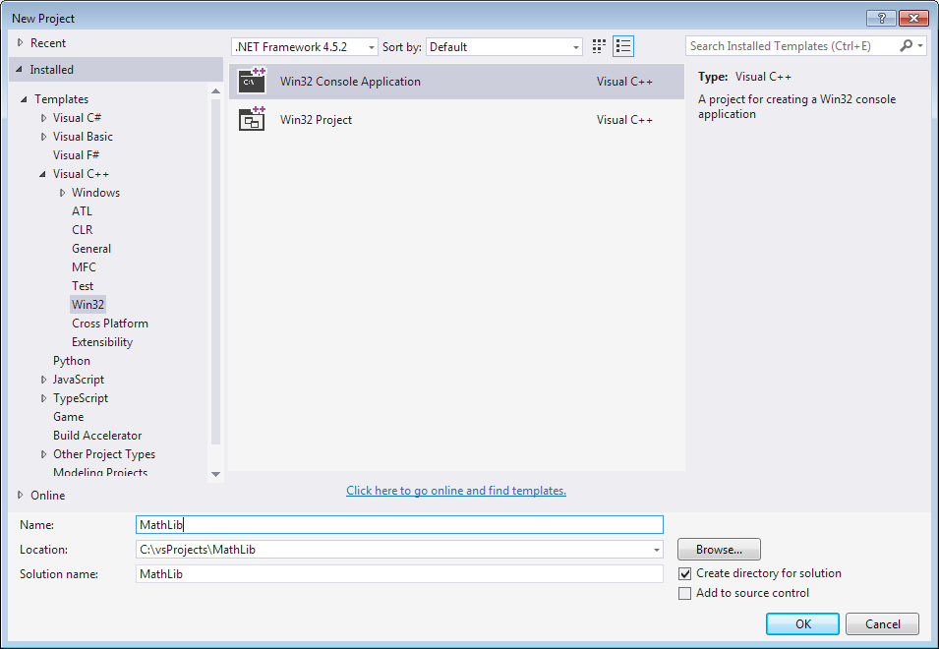

1. On the **Overview** page of the **Win32 Application Wizard** dialog box, choose the **Next** button.
2. On the **Application Settings** page, under **Application type**, select **Static library.**
3. On the **Application Settings** page, under **Additional options**, clear the **Precompiled header** check box.

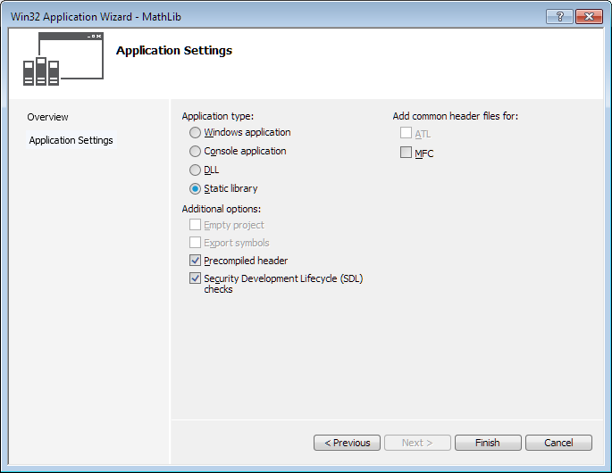

1. Choose the **Finish** button to create the project.

Creating a Project that Uses the Library:

1. Right click on the solution name and select **Add** -> **New Project…**

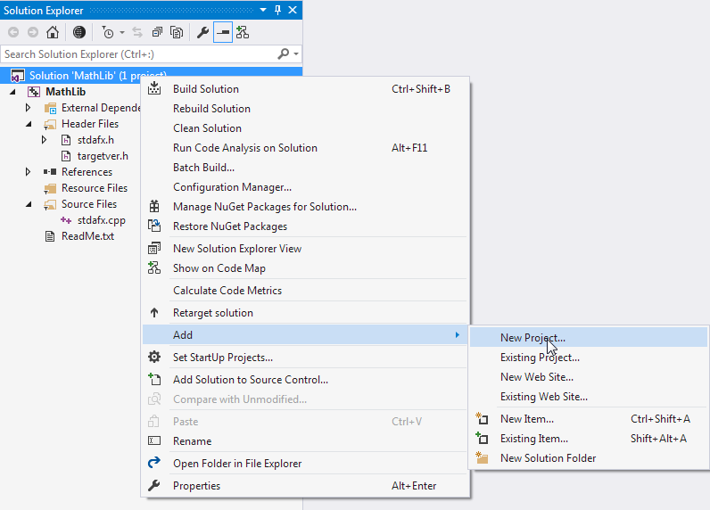

1. Create a new Win32 Console Application under the same directory as the solution

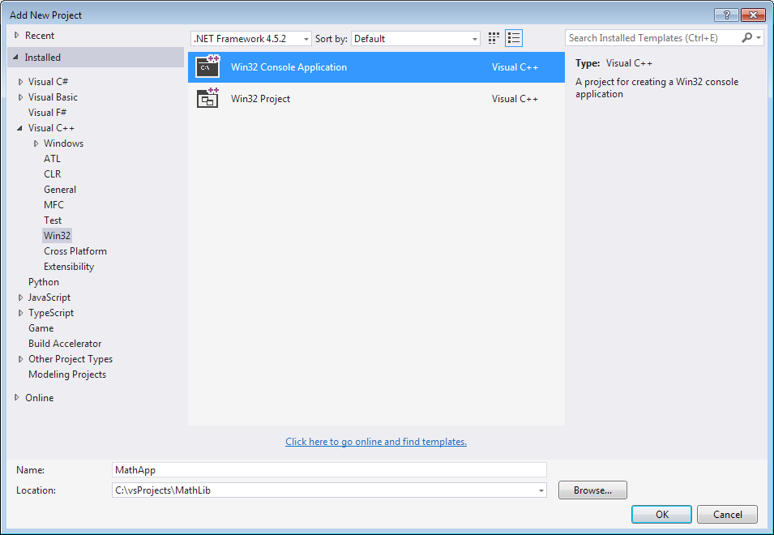

1. Make sure the project is set to create a **Console application**. Once the settings are correct, press **Finish**

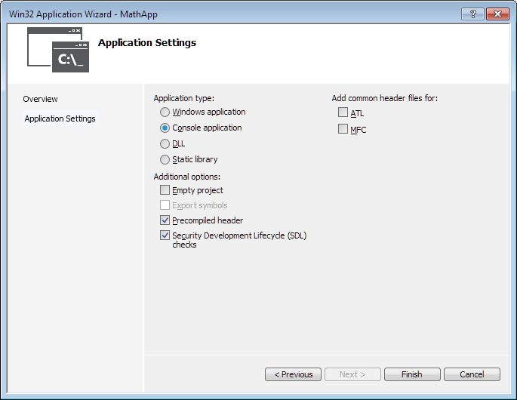

1. Set the Console application project to be the *StartUp* project. This means that when you run your solution, this project is the one that will run.  
   To do this, right click on the console application project and select **Set as StartUp Project**.
2. Now we need to setup the console application so that it references the library. Right click on the Console application’s name in the Solution Explorer and select **Add** -> **Reference…**.

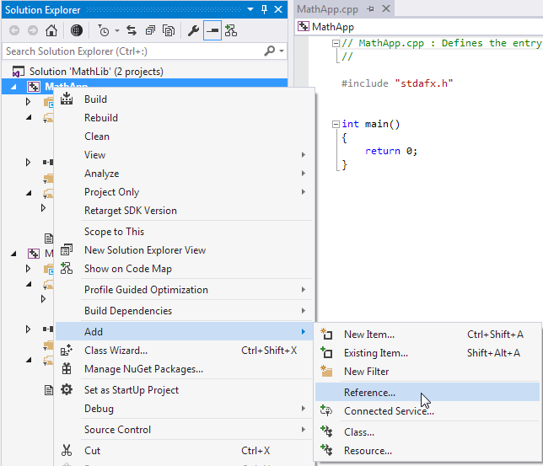

1. A new window will appear. Select the library project from the list and press OK.

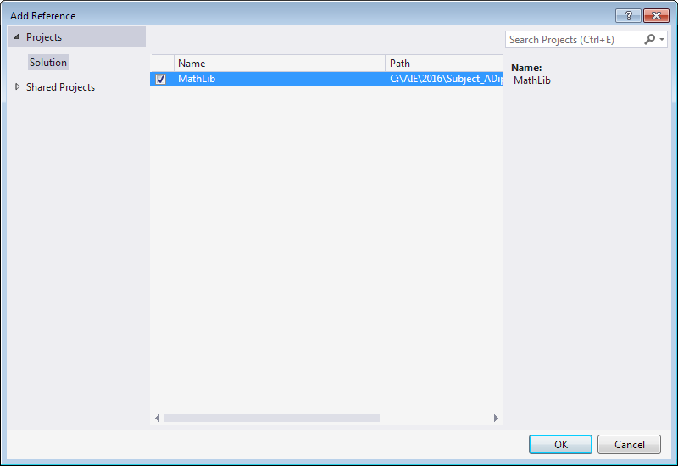

1. Your console application project is now linked with your static library, but we still need to tell the project were to find any header files for the library.  
   The library header files are necessary when compiling the application because they will tell the application what code is contained in the static library.  
   Right click on the console application project in Solution Explorer and select **Properties…**.
2. Navigate to the **C/C++** -> **General** settings and look for the **Additional Include Directories** field.  
   In this field type the following:  
    $(SolutionDir)\MathLib  
     
   This will tell the project to look for any missing header files in the *MathLib* directory under the solution directory (where the .sln file is located).  
   If you called your library by a different name be sure to modify this line using the appropriate directory.

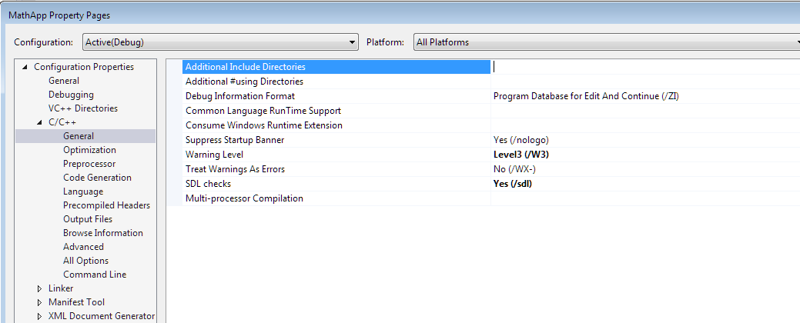

Your console application should now be linked with your library and be able to find the library’s header files when compiling.

But so far we haven’t included any code in the library for the application to use.

Create two new files in the library project called *Utility.h* and *Utility.cpp*.

Add the following code to the header file:

#pragma once

int add(int a, int b);

Go ahead and implement this function in *Utility.cpp*.

Finally, in the Console application project, open the .cpp file containing the *main*() function (the name of this file should be the same as the project’s name).

Modify the existing *main*() function as follows:

#include "Utility.h"

#include <iostream>

int main()

{

std::cout << add(10, 5) << std::endl;

system("pause");

return 0;

}

Compile and run the program. Your console application will now be using the *add*() function that you included in your library.

Challenge:

Creating a dynamically linked library is slightly more complicated that what has explained in this tutorial.

Follow this tutorial from the Microsoft Developer Network and see if you can create a dynamic link library (DLL) that has the same functionality as your static library.

Walkthrough: Creating and Using a Dynamic Link Library (C++): <https://msdn.microsoft.com/en-us/library/ms235636(v=vs.140).aspx>